Functional Specification

**Project Symphony Drop 2:**

**Dashboard, Outstanding Balance and Claims Module**

**Version 0.2**

# Revision Summary

|  |  |  |  |  |
| --- | --- | --- | --- | --- |
| Version No. | Date | Revision Description | Author(s) | Approver(s) |
| 0.1 | 27/03/2019 | Initial document based on URS listed below:   * UR for Project Symphony_General URS_Portal Foundation_V2 30.docx * Addendum for General URS_V2 00.docx * UR for Bill Revamping_AHS_V2.0.docx * UR - SOA - Billing transformation ver 5.3.docx * User Requirement for Project Symphony _ AHS_ClaimModule_Addendum2.docx | Nurul Iman |  |
| 0.2 | 10/9/2019 | Updated document per comments during FSD Walkthrough with IT teams (ESB, G400, SP, Staging Service, and Imaging DB). | Nurul Iman |  |

# Approval / Signoff

|  |  |  |  |
| --- | --- | --- | --- |
| Approver name and title | Function or Department | Signature or Email attachment | Signoff date |
| Ernie Hee | HOD/ AHS |  |  |
| Jenny Lee | HOD/ CSD |  |  |
| Choo Siew Wan | HOD/ CMX |  |  |
| Tan Kean Hong | IT Lead - Front End |  |  |
| Wong Jian Ming | IT Lead - Back End |  |  |

# Distribution List

|  |  |
| --- | --- |
| **Company / Department** | **Person / Group** |
| User Lead/ CX Customer Solutions | Eng Mei Keen |
| User Team Manager/ CCU | Tan Hwei Jen |
| User Team Manager/ CS-CSPPM | Fong Yin Cheng |
| User Team Manager/ CMX | Wong Wan Siong |
| User Team Manager/ CMX | Chan Lai Foong |
| User Team Member/ AHS | Zainatul Ashikin Kamal Sabri |
| User Team Member/ AHS | Janet Yeoh |
| User Team Member/ CMX - MiCare | Muthamah Maddacanno |
| IT Lead – Front End | Tan Kean Hong |
| IT Lead – Back End | Wong Jian Ming |
| BA – Back End | Madhan Kumar |
| IT SME – G400 | Wong Jian Ming |
| IT SME – ESB | Sharon Diana Saldanha |
| IT SME – CPF | Vijay Chandra Jaligama |
| IT SME – Backend Services | Srinivasa Rao Pamidimukkala |
| IT SME – Bicor | Chang Chee Wun / T.Komalavalli / Wong Choon Keat |
| IT SME – Email Gateway | Chang Chee Wun / Nik Fariz Nik Mohamed Noor |
| IT SME – Case360 | Chang Chee Wun / Nik Fariz Nik Mohamed Noor / Mohammad Azlan Yusof |

**Table of Contents**

Revision Summary 2

Approval / Signoff 3

Distribution List 4

1 Objective 7

2 Scope 7

2.1 In Scope 7

2.2 Out Scope 7

3 Current processing 7

4 Business Flow Diagram 7

5 Assumptions, dependencies and constraints 8

5.1 Assumptions 8

5.2 Dependencies 8

5.3 Constraints 8

6 Requirement trace index 9

7 Detailed functional descriptions 10

7.1 FR-001: Dashboard Overview 10

7.1.1 Retrieve Authorized Company List 11

7.1.2 Load Claim Count 11

7.1.3 Load Billing Count 12

7.1.4 Load Letter Count 12

7.1.5 Load Policy Document Count 13

7.1.6 Load Latest SOA Count and Total Outstanding Balance 13

7.2 FR-002: Outstanding Balance Overview 14

7.2.1 View Outstanding Balance Listing 14

7.3 FR-003: Claims Overview 15

7.3.1 Generate and Download Letter of Guarantee (LOG) 15

7.3.2 Generate and Download Claim Statement 15

7.3.3 Downloaded Claim Statement Folder Structure 16

8 Data requirements 17

9 Other requirements 17

10 Testing consideration 17

11 Interface consideration 17

12 Conversion consideration 17

12.1 Policy Type Criteria 17

12.2 Policy Status Criteria 18

13 Reference 19

13.1 Reference Documents 19

13.2 Systems Reference 19

13.3 Acronyms 19

14 Appendix 20

14.1 Sample LOG File Generated (Excel) 20

14.2 Wireframes 20

14.2.1 Dashboard Wireframes 21

14.2.2 Outstanding Balance Wireframes 21

14.2.3 Claim Wireframes 22

# Objective

This document outlines the functional specifications of the intermediate systems for Project Symphony Drop 2 Dashboard, Outstanding Balance and Claims module on the My AIA Corporate portal.

My AIA Corporate portal is a self-service portal that allows user to perform employee benefit related task without having to contact the call center for information.

This document does not include any details of processes, validations or data mapping that happens on portal and source systems. The details on portal and source system are covered in separate documents.

# Scope

## In Scope

|  |  |  |
| --- | --- | --- |
| No. | Sub-Modules | Features |
| 1 | Dashboard Overview | * Dashboard displaying:   + SOA Count and Outstanding Amount   + Billing document count   + Claims count   + Correspondence Letter count   + Policy document count |
| 2 | Outstanding Balance Overview | * SOA List displaying:   + Outstanding balance   + Latest correspondence letter |
| 3 | Claims Overview | * LOG report can be downloaded from Claim Dashboard * Claims Statement can be downloaded from Claim Listing |

## Out Scope

|  |  |  |
| --- | --- | --- |
| No. | Sub-Modules | Remarks |
|  |  |  |

# Current processing

Please refer to **Section 1** from the **UR Project Symphony_General Requirements v2.0**.

# Business Flow Diagram

The flow diagrams are separated by sections and are shown in each section before the functional descriptions.

# Assumptions, dependencies and constraints

## Assumptions

|  |  |
| --- | --- |
| **No.** | **Assumptions Description** |
| 1 |  |

## Dependencies

|  |  |  |
| --- | --- | --- |
| **No.** | **Dependencies Description** | **PIC/System** |
| 1 |  |  |

## Constraints

|  |  |
| --- | --- |
| **No.** | **Constraints Description** |
| 1 |  |

# Requirement trace index

|  |  |  |  |  |  |  |
| --- | --- | --- | --- | --- | --- | --- |
| Business requirement (BR) number | Functional requirement (FR) number | Description | Online change | Batch change | Screen design | New process flow |
| **General**  4.6 Main Dashboard | FR-001 | * Dashboard | Yes | No | Yes | Yes |
| **Addendum General**  6.0 Show dashboard based on selected company  7.0 Show outstanding balance amount on dashboard and redirect to outstanding details page upon click on amount | FR-001,  FR-002 | * Dashboard Overview * Outstanding Balance Overview | Yes | No | Yes | Yes |
| **Premium & Admin Fee Billing**  Requirement for OSC Portal (Internal) | FR-003 | * To enhance current E-Bill to be able to display full set of documents. * Allow AIA staff to search & view all billing documents uploaded up to min 7 years | Yes | No | Yes | Yes |
| **Bill Revamping**  E-notification of bills & self-service by clients/ intermediaries in Corporate Portal | FR-001,  FR-002,  FR-003,  FR-004 | * AIA Corporate Portal * AIA Internal Portal * E-notification | Yes | No | Yes | Yes |
| **SOA**  E-notification of bills & self-service by clients/ intermediaries in Corporate Portal | FR-004 | * E-notification | Yes | No | Yes | Yes |
| **AHS_ClaimModule_Addendum2**  4.1 Dashboard | FR-001 | * Dashboard for claims and LOG. * Download LOG report. |  |  |  |  |
| **Correspondence Letter**  4.1 Dashboard | FR-001 | * Dashboard for correspondence letter and policy. |  |  |  |  |
| **Claims** | FR-005 | * Claim Statement | Yes | No | Yes | Yes |

# Detailed functional descriptions

## FR-001: Dashboard Overview







|  |  |  |
| --- | --- | --- |
| Business Process | Functional Descriptions | Systems |
| Retrieve Authorized Company List  * Portal will populate the authorized company list when loading dashboard. * This is not applicable for AIA staff as the dashboard will be empty for staff login. * Refer to the wireframes here. | 1. When portal loads the dashboard page, *RetrieveAuthorizedCompany* API will be called to populate the company name drop down. 2. Once the API is called, ESB will:    * Retrieve all the authorized company from G400 Datamart based on the PIC’s debtor code in http header.    * The list will be sorted by company name in ascending order.    * If failed to retrieve, then pass error message to portal.    * If no data found, then pass no record found to portal.    * If data found, then pass the list to portal to be displayed. | ESB,  SP,  Datamart |
| Load Claim Count  * Portal will display the claim count for the latest 60 days up till yesterday for the selected company. * This is not applicable for AIA staff as the dashboard will be empty for staff login. * Refer to the wireframes here. | 1. When portal loads the dashboard page, *RetrieveClaimCount* API will be called to populate the claim count for the selected company. 2. Once the API is called, ESB will:    * Retrieve all the authorized policy from G400 Datamart based on the PIC login credential.    * If failed to retrieve, then pass error message to portal.    * If no data found, then pass no record found to portal.    * If data found, then retrieve the claim count from G400 Datamart for each claim type (Medical & Term Life / GPA) based on the rules below.      + Claim status Approved (CA and CC), Pending Processing (CP), Declined (CR).        - For medical claim, Whose Claim = Member.        - For term life, Whose Claim = All (Provider, Combination, Member).      + Pass CompanyLOGFacilityFlag as Y if company has LOG facility; else pass flag as N.      + LOG (Whose Claim = Provider, Combination)      + Claim with excess [Whose Claim = All (Provider, Combination, Member)]      + Retrieve claim count for up to 60 days, since yesterday, for latest policy period.    * If failed to retrieve the claim count, pass error message to portal to notify user.    * If success, pass the claim count to portal to be displayed. 3. If user select another company from the drop down, then ESB will repeat steps (2) above. | ESB,  SP,  Datamart |
| Load Billing Count  * Portal will display the billing document count for the latest 60 days up till yesterday for the selected company. * The bills are group by:   + Premium & admin fee bill   + ASO & ASO claim excess bill   + Claim excess bill   + Statement of Account (SOA) * Refer to the wireframes here. | 1. When portal loads the dashboard page, *RetrieveBillStatementCount* API will be called to populate the billing document count for the selected company. 2. Once the API is called, ESB will:    * Retrieve all the authorized policy from G400 Datamart based on the PIC login credential.    * If failed to retrieve, then pass error message to portal.    * If no data found, then pass no record found to portal.    * If data found, then retrieve the billing document count from Imaging DB based on the rules below.      + Retrieve claim count for up to 60 days, since yesterday, for latest policy period.    * If failed to retrieve the billing document count, pass error message to portal to notify user.    * If success, pass the count to portal to be displayed. 3. If user select another company from the drop down, then ESB will repeat steps (2) above. | ESB,  Imaging DB |
| Load Letter Count  * Portal will display the letter count for the latest 60 days up till yesterday for the selected company. * The letters are group by:   + Underwriting Letter   + Enrolment Notification   + Termination of Policy   + Notification of Suspension   + Outstanding Reminder Letter   + Payment and Refund * Refer to the wireframes here. | 1. When portal loads the dashboard page, *RetrieveCorrespondenceLetterCount* API will be called to populate the letter count for the selected company. 2. Once the API is called, ESB will:    * Retrieve all the authorized policy from G400 Datamart based on the PIC login credential.    * If failed to retrieve, then pass error message to portal.    * If no data found, then pass no record found to portal.    * If data found, then retrieve the letter count from Imaging DB based on the rules below.      + Retrieve letter count for up to 60 days, since yesterday, for latest policy period.    * If failed to retrieve the letter count, pass error message to portal to notify user.    * If success, pass the count to portal to be displayed. 3. If user select another company from the drop down, then ESB will repeat steps (2) above. | ESB,  Imaging DB |
| Load Policy Document Count  * Portal will display the policy document count for the latest 60 days up till yesterday for the selected company. * Refer to the wireframes here. | 1. When portal loads the dashboard page, *RetrievePolicyCount* API will be called to populate the policy document count for the selected company. 2. Once the API is called, ESB will:    * Retrieve all the authorized policy from G400 Datamart based on the PIC login credential.    * If failed to retrieve, then pass error message to portal.    * If no data found, then pass no record found to portal.    * If data found, then retrieve the policy document count from Imaging DB based on the rules below.      + Retrieve letter count for up to 60 days, since yesterday, for latest policy period.    * If failed to retrieve the policy document count, pass error message to portal to notify user.    * If success, pass the count to portal to be displayed. 3. If user select another company from the drop down, then ESB will repeat steps (2) above. | ESB,  Imaging DB |
| Load Latest SOA Count and Total Outstanding Balance  * Portal will display the latest number of policies with outstanding balance and the total aggregated balance for the master company, including its subsidiary. * The total aggregated balance is the outstanding balance count for the master company and its subsidiary. * The last statement date is populated by the latest outstanding balance for the master company and its subsidiary. * Refer to the wireframes here. | 1. When portal loads the dashboard page, *RetrieveOutstandingBalanceSummary* API will be called to populate the outstanding balance summary for the selected company. 2. Once the API is called, ESB will:    * Retrieve all the authorized policy from G400 Datamart based on the PIC login credential.    * If failed to retrieve, then pass error message to portal.    * If no data found, then pass no record found to portal.    * If data found, then retrieve the outstanding balance summary from Imaging DB based on the rules below.      + Retrieve the latest outstanding balance summary for all the authorized policy.      + If the selected company if a subsidiary company, then retrieve the policy no. and outstanding balance for both master and subsidiary company of the selected company.    * If failed to retrieve the summary details, pass error message to portal to notify user.    * If success, pass the summary details to portal to be displayed. 3. If user select another company from the drop down, then ESB will repeat steps (2) above. | ESB,  Imaging DB |

## FR-002: Outstanding Balance Overview

|  |  |  |
| --- | --- | --- |
| Business Process | Functional Descriptions | Systems |
| View Outstanding Balance Listing  * Portal will populate the outstanding balance for each policy once user click to View List button. * The search result will always populate master company name even if the selected company name is a subsidiary company. * User will be able to download the latest SOA and correspondence letters for each policy. * User can only download 1 file at a time (either SOA or letter depending on which is being clicked). * Upon user click on the download button, no API will be called as the link is already provided in the API. * Refer to the wireframes here. | 1. When portal loads the outstanding listing page, *RetrieveOutstandingBalanceListing* API will be called to populate the outstanding balance listing or the selected company. 2. Once the API is called, ESB will:    * Retrieve all the authorized policy from G400 Datamart based on the PIC login credential.    * If failed to retrieve, then pass error message to portal.    * If no data found, then pass no record found to portal.    * If data found, then retrieve the outstanding balance listing from Imaging DB based on the rules below.      + Retrieve the latest outstanding balance listing for all the authorized policy.      + Retrieve the link for latest SOA and letters for each policy.      + If the selected company name if a subsidiary company, then retrieve the master company name of the subsidiary.      + The listing will be sorted by policy no. in ascending order.    * If failed to retrieve the listing, pass error message to portal to notify user.    * If success, pass the listing to portal to be displayed. | ESB,  Imaging DB |

## FR-003: Claims Overview

|  |  |  |
| --- | --- | --- |
| Business Process | Functional Descriptions | Systems |
| Generate and Download Letter of Guarantee (LOG)  * User can download LOG listing upon clicking on claim dashboard LOG count record. * Refer to sample generated LOG file here. | 1. Once user clicks on download button, portal will call *DownloadLOG* API to start the LOG file generation process. 2. Once the API is called, ESB will:    * Retrieve the LOG listing from G400 Datamart based on the search criteria.    * The listing will be sorted per below criteria (in sequence).      1. Employee name ascending      2. Guarantee Letter Issuance Date ascending    * Store the download request into request table in Staging DB with status as Requested.    * Notify Staging Service to proceed with the file generation. 3. Once notified, Staging Service will:    * Check the type of request.    * Retrieve the download request data from Staging DB.    * If data not found, then update the request status as Failed in Staging DB.    * If data found, then populate the data into Excel file.    * The name format for the generated excel is GUARANTEELETTER_<date timestamp YYYYMMDD hhmmsss>.xlsx.    * If the file generation failed, then update the request status in Staging DB as Failed.    * If the file generation successful, then update the request status in Staging DB as Success and store the generated file into notification table in Staging DB with file status as unread (this is for download count purposes). 4. Once the download file is ready, portal will display notification and user can download the file via the download notification or the download page. | ESB,  Datamart,  Staging Service |
| Generate and Download Claim Statement  * User can download the claim statement by:   + Select single or multiple document from the search result.   + Bulk download for all search result in the selected page no. * The selected document will be grouped by policy no. and consolidated into 1 zip file. * Refer to the claim wireframes here. | 1. Once user clicks on download button, portal will call *DownloadClaimStatement* API to start the download process of the selected claim statement. 2. Once the API is called, ESB will:    * Check the download criteria. If policy no. is not provided, then retrieve the authorized policies from the temp table.    * Retrieve the claim statement from Imaging DB based on the download criteria.    * Store the download request with details into request table in Staging DB with status as Requested.    * Notify Staging Service to proceed with the file compilation. 3. Once notified, Staging Service will:    * Check the type of request.    * Retrieve the download request data from Staging DB.    * If data not found, then update the request status as Failed in Staging DB.    * If data found, then get the actual file in Imaging DB using the GUID given in SP and compile the statements into a single zip file.    * The downloaded file name will follow the format as <Claim No.>_CLAIMSTATEMENT.pdf    * Refer to the folder structure of the zip file here.    * If the file compilation failed, then update the request status as Failed in Staging DB.    * If the file compilation successful, then update the request status as Success in Staging DB and store the zip file into notification table in Staging DB with file status as unread (this is for download count purposes). 4. Once the download file is ready, portal will display notification and user can download the file via the download notification or the download page. | ESB,  SP,  Imaging DB,  Staging Service |

### Downloaded Claim Statement Folder Structure

* The folder structure of the downloaded claim statement zip file will be as below.
  + Zip file: CLAIMSTATEMENT_<date timestamp YYYYMMDD hhmmsss>.zip
  + Primary folder: CLAIMSTATEMENT_<date timestamp YYYYMMDD hhmmsss>
* For example:

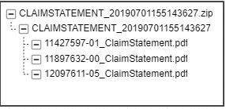

# Data requirements

Data mapping will be in a separate excel file which covers mapping between portal to ESB and ESB to G400 and Case360.

# Other requirements

Not applicable.

# Testing consideration

Test cases will be created by the Business User after the requirements’ freeze period, which will be later than this FSD completion. Hence it will not be included in this document.

However, the test cases are necessary during the technical design to ensure that the development covers all test scenarios.

# Interface consideration

Not applicable.

# Conversion consideration

## Policy Type Criteria

|  |  |  |  |
| --- | --- | --- | --- |
| No. | Portal View | G400 Value | ESB Logic |
| 1 | Conventional | Company 3 | Check field CHDRCOY, where Company 3 = Conventional |
| 2 | Takaful | Company 4 | Check field CHDRCOY, where Company 4 = Takaful |

## Policy Status Criteria

|  |  |
| --- | --- |
| **Step 1: ESB Logic** | |
| 1. Exclude Policy Corrupted = Y and Declined policy in G400. | |
| 1. If G400 status = PN, return status as “**New Business In Progress**”. 🡪 excluded from portal 2. If G400 status = PR, return status as “**Renewal In Progress**”. 3. If G400 policy status = PN or PR, Check in G400 TM99V, if the policy found in that table with valid flag = Y, then status is **Suspended**. 4. If G400 status = LA or CA, return status as “**Inactive**”. | |
| 1. If G400 status is IF or PE and Policy Inactive indicator is not “Y”, then check in Case360 using logic below. | |
| **Step 2: Case360 Logic** | |
| **POS** | **Renewal** |
| 1. Check latest Active, Closed/ Completed cases for Non-adjustment with policy termination box checked only. 2. Renewal Billing adjustment user not null only. 3. If found, compare the effective date <= today return status “**Inactive**”. 4. If found, compare the effective date > today return status “**Active**”. | 1. Check latest Active, Closed/ Completed cases and renewal adjustment user not null only. 2. If found and tick lost, Case360 PolicyFrom date <= today, return status “**Expired**”. 3. If found and tick lost, Case360 PolicyFrom date > today, return status “**Active**”. 4. If found and untick lost, Case360 PolicyFrom date > G400 PolicyTo date, return status “**Renewal In Progress**”. 5. If found and untick lost, Case360 PolicyFrom date <= G400 PolicyTo date, then check:    1. If G400 date <= today, then return “**Expired**”    2. If G400 date > today, then return “**Active**” |
| 1. If cases found in both type, take the latest case. 2. If cases NOT found in both type (POS and Renewal), and:    1. If G400 date <= today, then return “**Expired**”    2. If G400 date > today, then return “**Active**” 3. If status is null from Case360, then check:    1. If G400 date <= today, then return “**Expired**”    2. If G400 date > today, then return “**Active**” | |
| **Step 3: ESB Logic** | |
| 1. If policy status is **Active** from case360, Check in G400 TM99V, if the policy found in that table with valid flag = Y, then status is **Suspended**. | |

# Reference

## Reference Documents

|  |  |  |
| --- | --- | --- |
| **No.** | **File Name** | **File Description** |
| 1 | User Access Matrix_V6 10_20181221.xlsx | User Access Matrix. |
| 2 | User Requirement for Project Symphony _ AHS_ClaimModule_Addendum2.docx | User Requirement for Claims Statement. |
| 3 | UR for Project Symphony_General URS_Portal Foundation_V2 30 | User Requirement for General. |
| 4 | Addendum for General URS_V2 00.docx | Addendum on General User Requirement. |
| 5 | UR for Project Symphony_Correspondence Letter_V2 10.docx | User Requirement for Correspondence Letter and Policy Matters. |

## Systems Reference

|  |  |
| --- | --- |
| **Application** | **Scope of Work** |
| ESB | Average of 80~100 new APIs to be created, for transactions & pulling data |
| Staging Services | Creation of new ones to facilitate real-time transactions between portal & backend |
| CPF | Enhancements to manage account/profile creation & role management |
| G400 | Enhancements to process real-time transactions from Portal |
| G400 MIMIX | Real-time replication of G400 database which can fulfilled the real-time request for MY AIA Corporate |
| Medi-Connect | Enhancement to pulling the claims info for MY AIA Corporate |
| Case 360 | Enhancement to pulling the Policy info for MY AIA Corporate |
| Callidus | Enhancement to pulling the Agent Hierarchy for MY AIA Corporate |
| CRM | Enhancement to pulling the claims info for MY AIA Corporate |
| Bicor/Print Agent | Enhancement to pre-generate all the Claims, Policies and Billing Documents for My AIA Corporate |
| Email Gateway | An Email Gateway allowed the scheduled service to massage the data and send all email notifications |

## Acronyms

|  |  |
| --- | --- |
| **Acronyms** | **Descriptions** |
| ESB | Enterprise Service Bus |
| AMSC | AIA MyService Corporate |
| CPF | Core Portal Framework |
| CRM | Enhancements to process real-time transactions from Portal |
| API | Application Programming Interface |
| AEM | Adobe Experience Manager |
| Portal | MyAIA Corporate Portal |

# Appendix

## Sample LOG File Generated (Excel)



The fields in the generated LOG are as follows (all fields are mandatory):

1. POLICY NO.
2. COMPANY NAME 🡪 Populate full name (Line 1 and 2)
3. EMPLOYEE NAME
4. MEMBERSHIP NO.
5. EMPLOYEE ID 🡪 If the data value is BLANK, to default as “N/A’.
6. CLAIMANT NAME
7. RELATIONSHIP 🡪 Populate the wording, refer here
8. PRODUCT CODE
9. PRODUCT DESCRIPTION 🡪 Populate long description as per G400 Table T9797
10. HOSPITAL / CLINIC / SPECIALIST 🡪 Populate full name (Line 1 and 2)
11. GUARANTEE LETTER REF NO.
12. GUARANTEE LETTER ISSUANCE DATE 🡪 Populate the Oldest Claim No. & Smaller Occurrence No.

The default sorting sequence for the listing will be as below.

* Employee name ascending
* Guarantee Letter Issuance Date ascending

## Wireframes

The wireframes can be accessed via the URL: <https://projects.invisionapp.com/share/3MSQPXN6GKA#/screens/370203246>

### Dashboard Wireframes

The dashboard wireframes are as below.

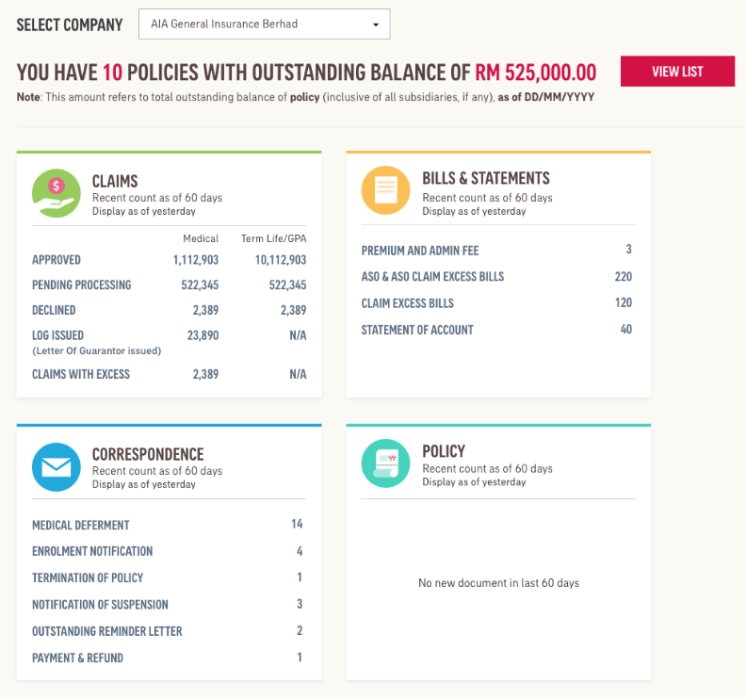

### Outstanding Balance Wireframes

The outstanding balance wireframes are as below.

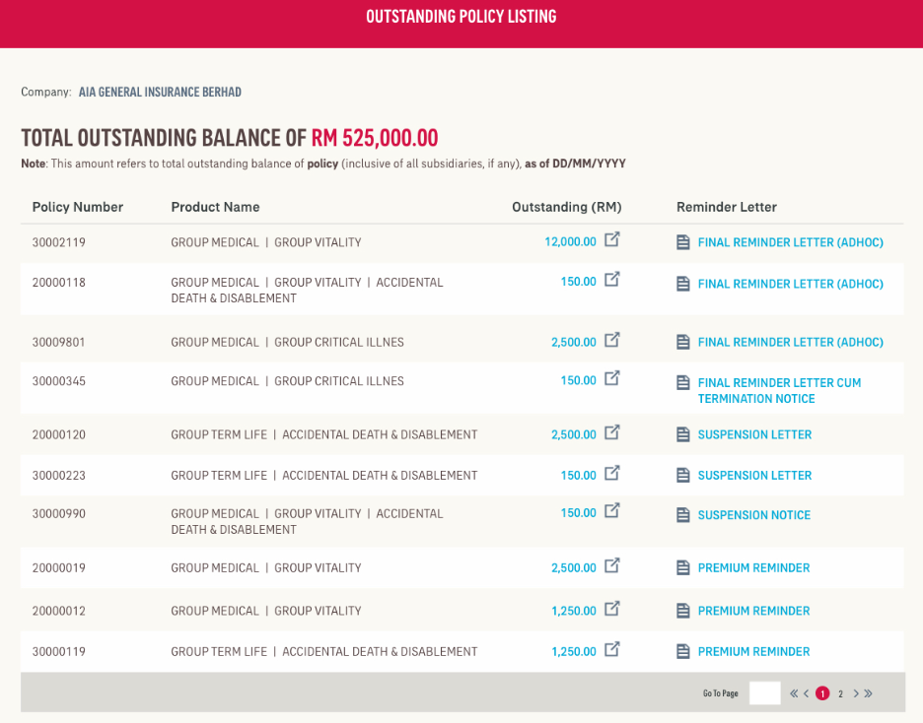

### Claim Wireframes

The claim wireframes are as below.

